BÁO CÁO THỰC HÀNH LAB 1  
LẬP TRÌNH HƯỚNG ĐỐI TƯỢNG

# 2. First Programs

## 2.1 Java Programming Steps

### 2.2.1 Write, compile the first Java application:

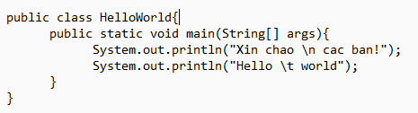

*Result*

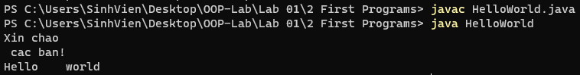

### 2.2.2 Write, compile the first dialog Java program.

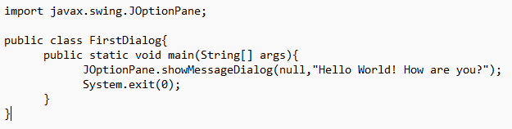

*Result*

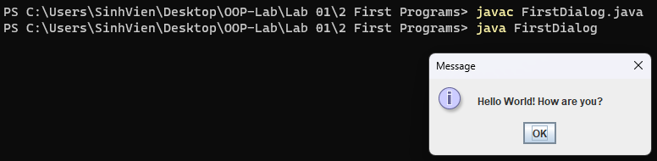

### 2.2.3 Write, compile the first input dialog Java application.

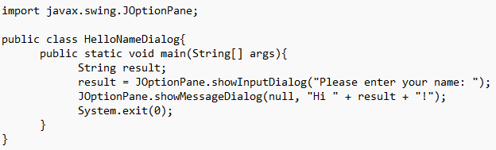

*Result*

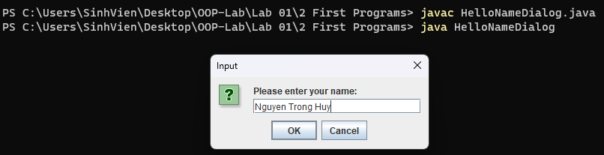

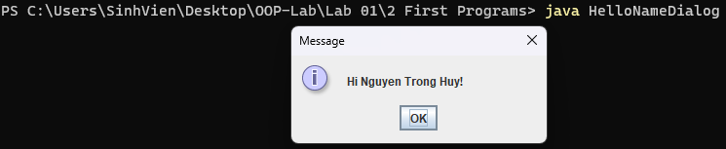

### 2.2.4 Write, compile, and run the following example:

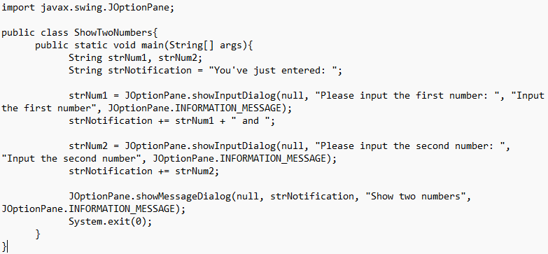

*Result*

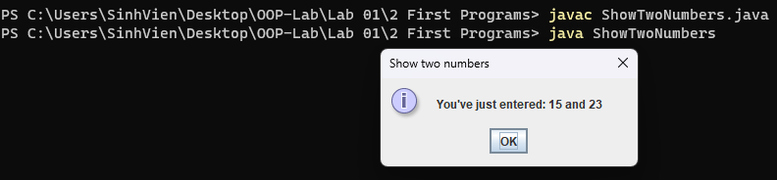

### 2.2.5 Write a program to calculate sum, difference, product, and quotient of 2 double numbers which are entered by users.

**Notes**

* To convert from String to double, you can use.

**double num1 = Double.parseDouble(strNum1)**

* Check the divisor of the division.

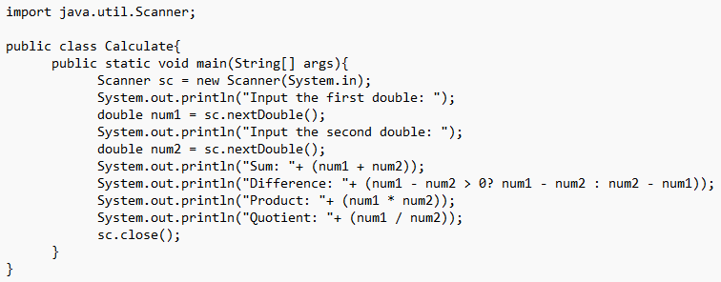

*Result*

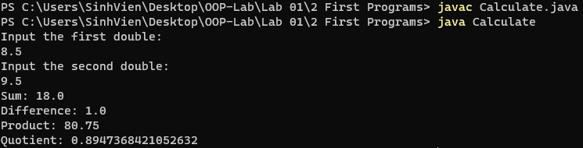

### 2.2.6 Write a program to solve:

#### - The first-degree equation (linear equation) with one variable

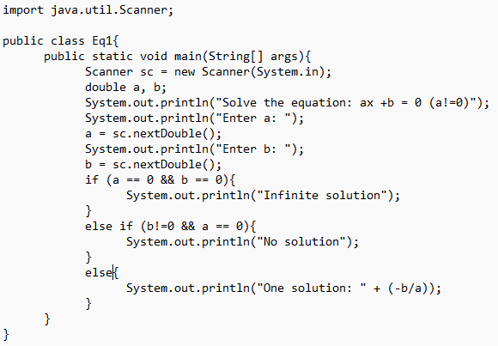

*Result*

#### - The system of first-degree equations (linear system) with two variables

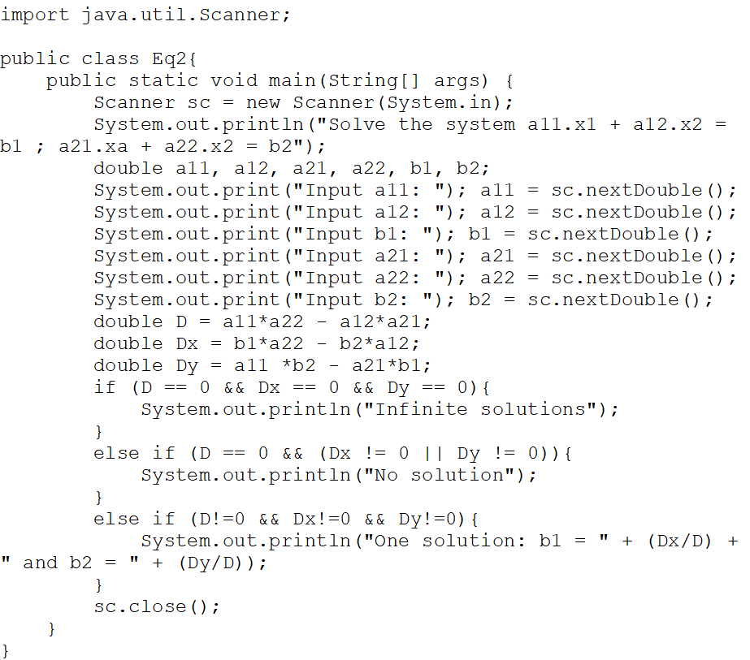

*Result*

#### - The second-degree equation with one variable

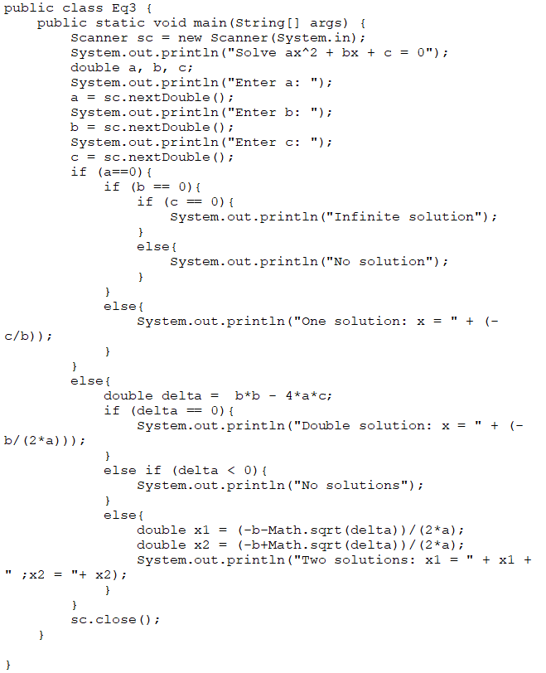

*Result*

# 6. Exercises

## 6.1 Write, compile, and run the ChoosingOption program:

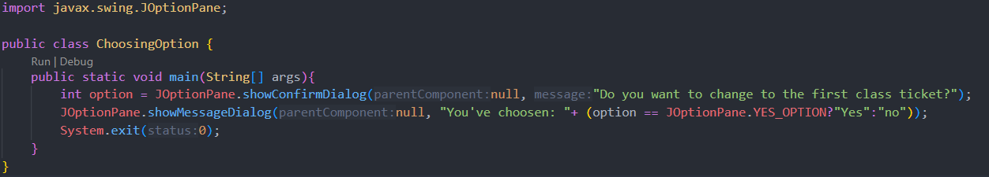

*Result*

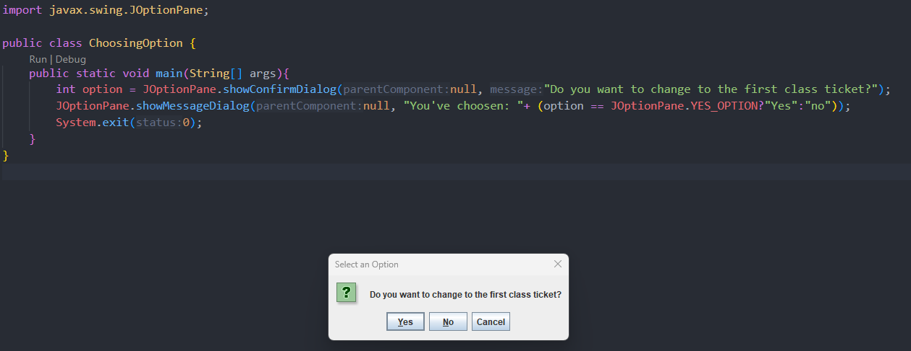

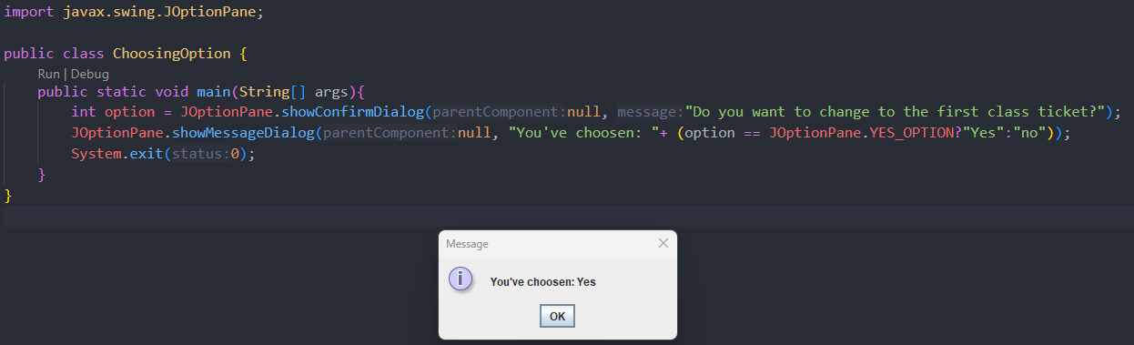

## 6.2 Write a program for input/output from keyboard.

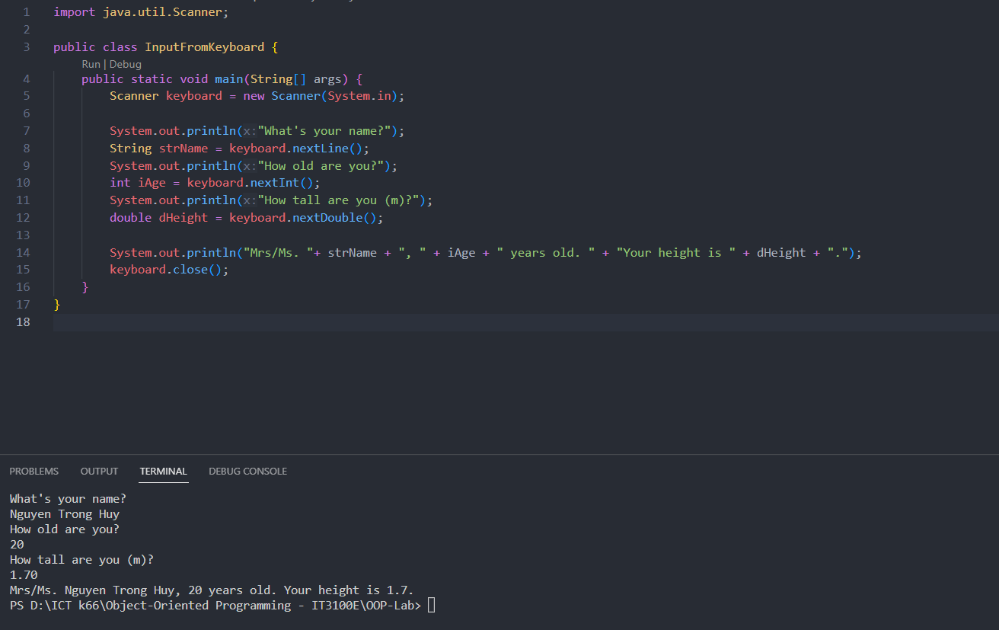

## 6.3 Write a program to display a triangle with a height of n stars (*), n is entered by users.

*Result*

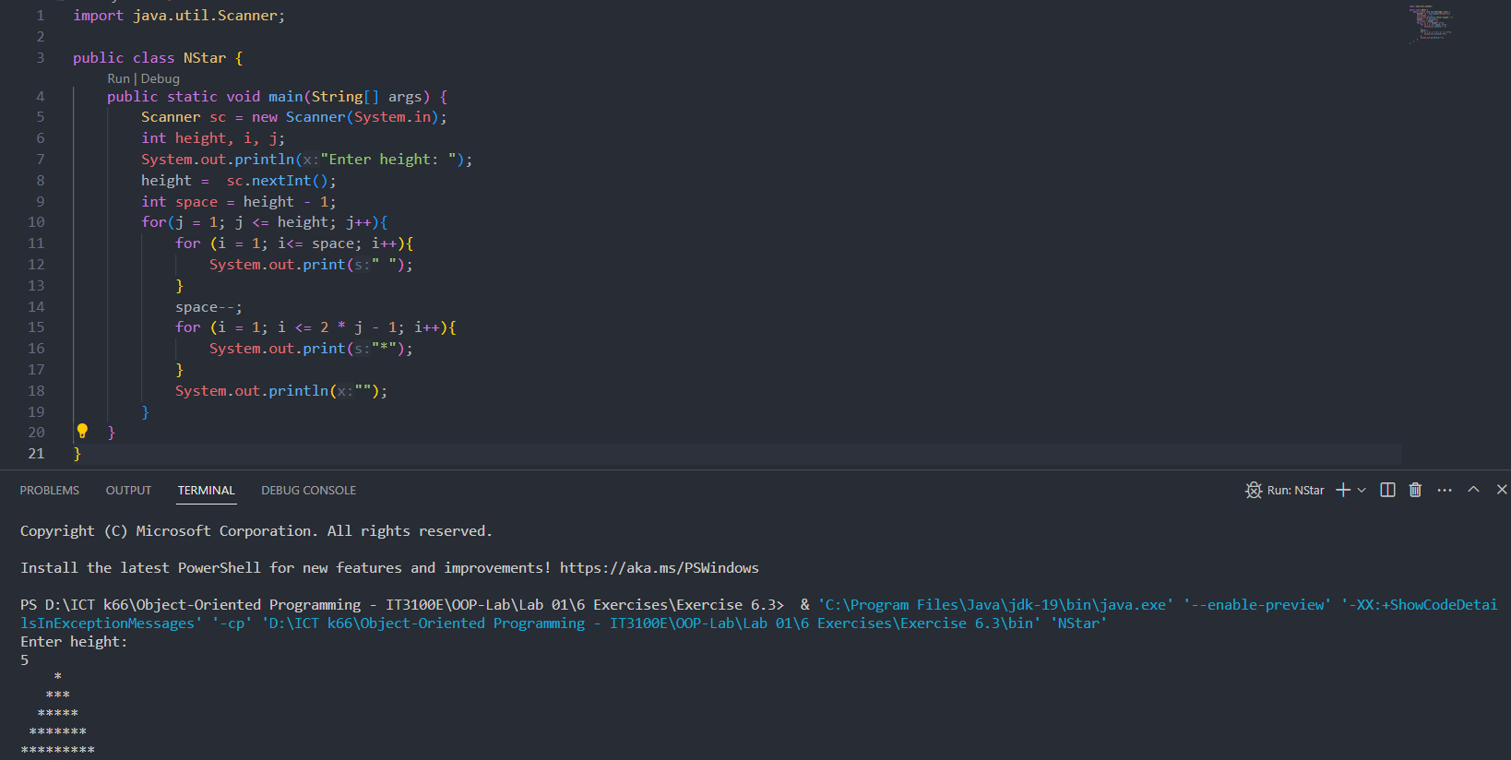

## 6.4 Write a program to display the number of days of a month.

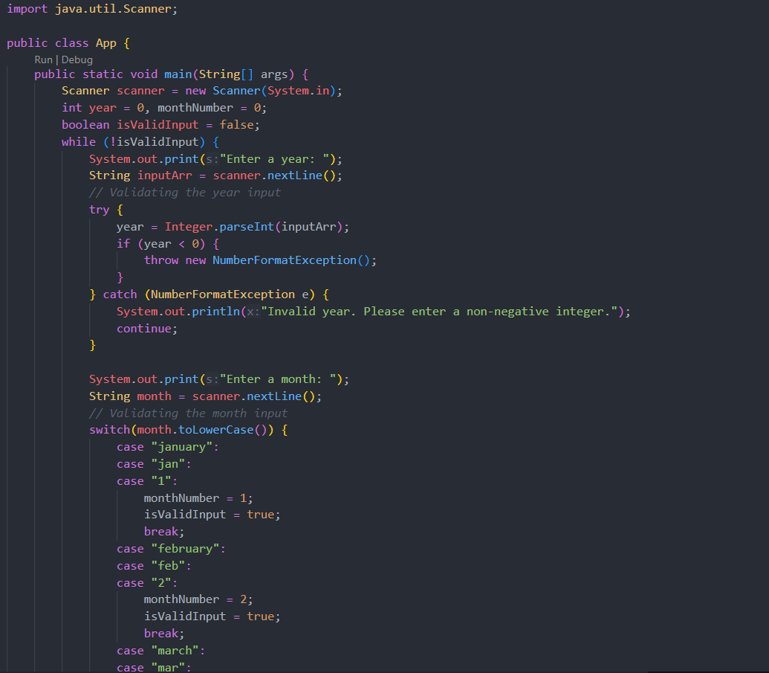

## 6.5 Write a Java program to sort a numeric array, and calculate the sum and average value of array elements.

*Result*

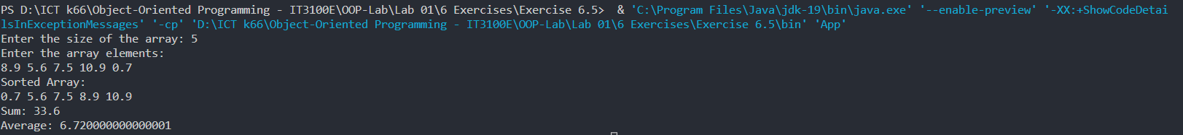

## 6.6 Write a Java program to add two matrices of the same size.

*Result*

